Steps :

1. From Apps in MS Teams Download Power Automate

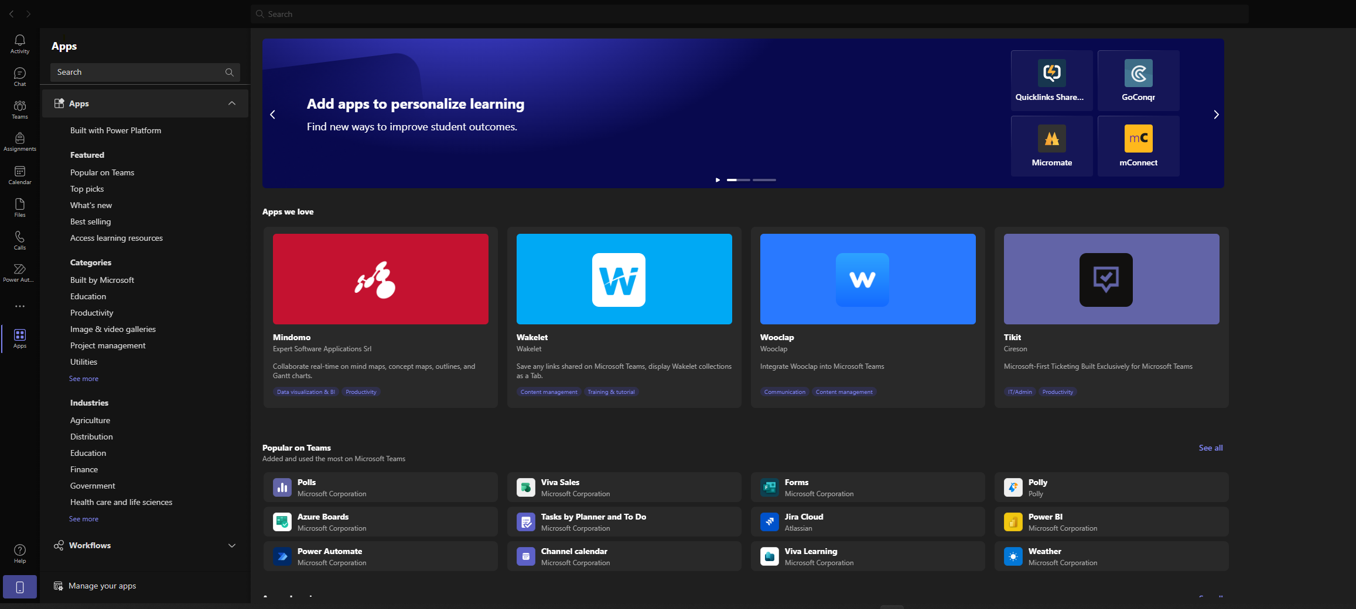

1. once installed you should be able to see the app on the left side.

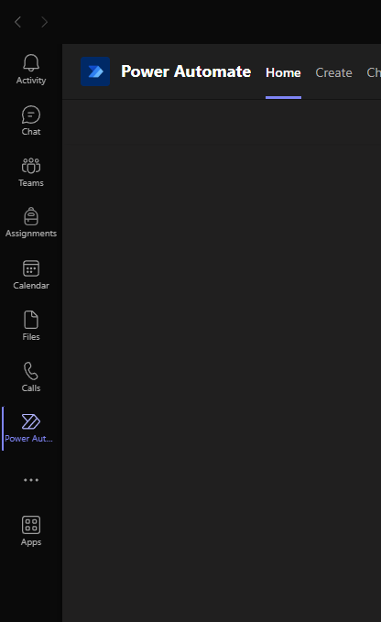

1. Create a Team from the Teams Icon and then create a Channel ( here its called Task Management )

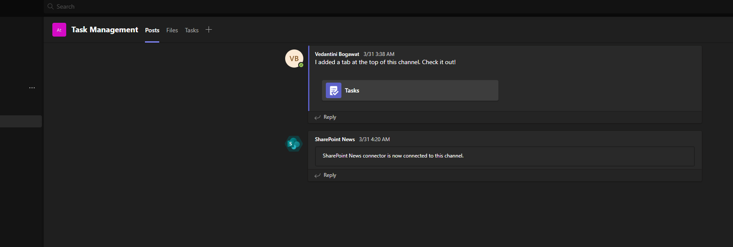

1. Add Tasks by Planner by clicking on the + symbol and this is how it should look.

1. Click on Tasks and Add Buckets

Buckets would be the various stages of your task.

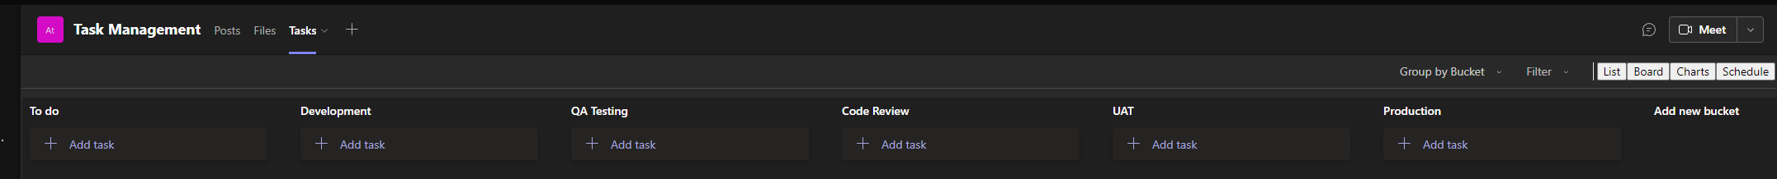

Besides the Default ToDo bucket, I have created Development ( for in Progress Tasks), QA Testing ( indicates the task is being tested in QA environment , Code review ( here a senior developer is assigned to as task to ensure coding practices are met as well as checks on versions of code and any undesirable changes to existing working), UAT , Production ( indicating task is completed and is deployed to production environment )

You can add buckets as required.

Lets Get on with the flows!

Open documents

1. Get Notified when File is Added
2. Get Notified when Tasks are added
3. Get Notified for Approvals.